What is a subquery in Oracle?
In Oracle, a subquery is a query within a query. We can create subqueries within our SQL statements. These subqueries can reside in the WHERE clause, in the FROM clause, or in the SELECT clause.
Example to understand Oracle Subquery
We are going to use the following Employee table to understand Subquery in Oracle with Examples.
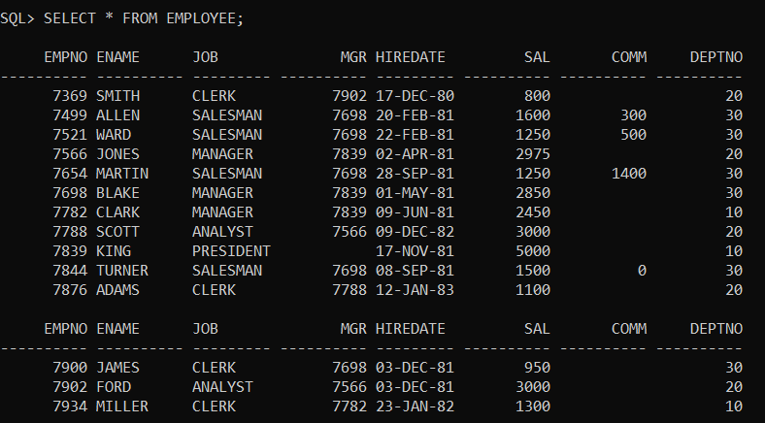
Please use the below SQL Script to create and populate the Employee and Dept table with the required sample data.
CREATE TABLE EMPLOYEE
(
EMPNO NUMBER(4) NOT NULL,
ENAME VARCHAR2(10),
JOB VARCHAR2(9),
MGR NUMBER(4),
HIREDATE DATE,
SAL NUMBER(7, 2),
COMM NUMBER(7, 2),
DEPTNO NUMBER(2)
);
INSERT INTO EMPLOYEE VALUES (7369, 'SMITH', 'CLERK', 7902, TO_DATE('17-DEC-1980', 'DD-MON-YYYY'), 800, NULL, 20);
INSERT INTO EMPLOYEE VALUES (7499, 'ALLEN', 'SALESMAN', 7698, TO_DATE('20-FEB-1981', 'DD-MON-YYYY'), 1600, 300, 30);
INSERT INTO EMPLOYEE VALUES (7521, 'WARD', 'SALESMAN', 7698, TO_DATE('22-FEB-1981', 'DD-MON-YYYY'), 1250, 500, 30);
INSERT INTO EMPLOYEE VALUES (7566, 'JONES', 'MANAGER', 7839, TO_DATE('2-APR-1981', 'DD-MON-YYYY'), 2975, NULL, 20);
INSERT INTO EMPLOYEE VALUES (7654, 'MARTIN', 'SALESMAN', 7698, TO_DATE('28-SEP-1981', 'DD-MON-YYYY'), 1250, 1400, 30);
INSERT INTO EMPLOYEE VALUES (7698, 'BLAKE', 'MANAGER', 7839, TO_DATE('1-MAY-1981', 'DD-MON-YYYY'), 2850, NULL, 30);
INSERT INTO EMPLOYEE VALUES (7782, 'CLARK', 'MANAGER', 7839, TO_DATE('9-JUN-1981', 'DD-MON-YYYY'), 2450, NULL, 10);
INSERT INTO EMPLOYEE VALUES (7788, 'SCOTT', 'ANALYST', 7566, TO_DATE('09-DEC-1982', 'DD-MON-YYYY'), 3000, NULL, 20);
INSERT INTO EMPLOYEE VALUES (7839, 'KING', 'PRESIDENT', NULL, TO_DATE('17-NOV-1981', 'DD-MON-YYYY'), 5000, NULL, 10);
INSERT INTO EMPLOYEE VALUES (7844, 'TURNER', 'SALESMAN', 7698, TO_DATE('8-SEP-1981', 'DD-MON-YYYY'), 1500, 0, 30);
INSERT INTO EMPLOYEE VALUES (7876, 'ADAMS', 'CLERK', 7788, TO_DATE('12-JAN-1983', 'DD-MON-YYYY'), 1100, NULL, 20);
INSERT INTO EMPLOYEE VALUES (7900, 'JAMES', 'CLERK', 7698, TO_DATE('3-DEC-1981', 'DD-MON-YYYY'), 950, NULL, 30);
INSERT INTO EMPLOYEE VALUES (7902, 'FORD', 'ANALYST', 7566, TO_DATE('3-DEC-1981', 'DD-MON-YYYY'), 3000, NULL, 20);
INSERT INTO EMPLOYEE VALUES (7934, 'MILLER', 'CLERK', 7782, TO_DATE('23-JAN-1982', 'DD-MON-YYYY'), 1300, NULL, 10);
Example:
The following query uses the MAX() aggregate function to return the highest salary from the Employee table.
SELECT MAX( SAL ) FROM EMPLOYEE;
Output:
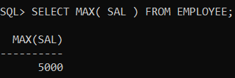
To select the detailed information of the highest-paid employee, we use the highest Salary (5000) in the following query.
SELECT * FROM EMPLOYEE WHERE SAL = 5000;
Output:
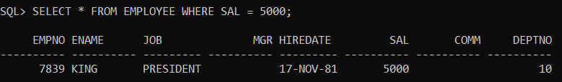
As you can notice, we need to execute two queries separately to get the highest-paid employee information from the Employee table. By using a subquery, we can nest the first query inside the second one as shown in the following statement.
SELECT * FROM EMPLOYEE WHERE SAL = (SELECT MAX( SAL ) FROM EMPLOYEE);
Output:
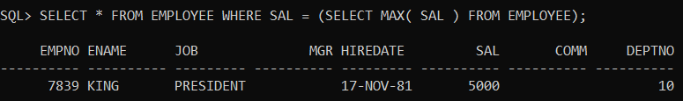
In the above example, the query that retrieves the max salary is called the subquery, and the query that selects the detailed employee data is called the outer query. We can say that the subquery or inner query is nested within the outer query. Note that a subquery must appear within parentheses (). Oracle evaluates the whole query in two steps:
- First, execute the subquery.
- Second, use the result of the subquery in the outer query.
Note: A subquery that is nested within the FROM clause of the SELECT statement is called an inline view. A subquery nested in the WHERE clause of the SELECT statement is called a nested subquery.
Subqueries in Oracle
A query inside another query is called a subquery or nested query in Oracle. The subquery is having two more queries. those are as follows,
- Inner / Child / Sub query
- Outer / Parent / Main query
Syntax: SELECT * FROM <TN> WHERE <CONDITION> (SELECT * FROM ………………);
As per the execution process of the subquery, it is again classified into two categorized.
- Non-Correlated Subqueries: In non-correlated subqueries, first, the inner query will execute and return value, and later outer query will execute.
- Correlated Subqueries: In Correlated subqueries first outer query will execute and return value and later inner query will execute.
The Non-Correlated Subqueries are again classified into 4 types are as follows.
- Single Row Subquery
- Multiple Row Subquery
- Multiple Column Subquery
- Inline View Subquery
Advantages of Oracle Subqueries
The following are the main advantages of subqueries:
- Provide an alternative way to query data that would require complex joins and unions.
- Make the complex queries more readable.
- Allow a complex query to be structured in a way that it is possible to isolate each part.

Single Row Subquery in Oracle
When a Subquery returns a single value is called a Single Row Subquery. In Single Row Subquery we can use operators such as = , < , > , <= , >=,!=. Let us see a few examples for a better understanding of the Single Row Subquery in Oracle.

Example to understand Single Row Subquery in Oracle
We are going to use the following Employee table to understand Single Row Subquery in Oracle with Examples.
Please use the below SQL Script to create and populate the Employee table with the required sample data.
CREATE TABLE EMPLOYEE
(
EMPNO NUMBER(4) NOT NULL,
ENAME VARCHAR2(10),
JOB VARCHAR2(9),
MGR NUMBER(4),
HIREDATE DATE,
SAL NUMBER(7, 2),
COMM NUMBER(7, 2),
DEPTNO NUMBER(2)
);
INSERT INTO EMPLOYEE VALUES (7369, 'SMITH', 'CLERK', 7902, TO_DATE('17-DEC-1980', 'DD-MON-YYYY'), 800, NULL, 20);
INSERT INTO EMPLOYEE VALUES (7499, 'ALLEN', 'SALESMAN', 7698, TO_DATE('20-FEB-1981', 'DD-MON-YYYY'), 1600, 300, 30);
INSERT INTO EMPLOYEE VALUES (7521, 'WARD', 'SALESMAN', 7698, TO_DATE('22-FEB-1981', 'DD-MON-YYYY'), 1250, 500, 30);
INSERT INTO EMPLOYEE VALUES (7566, 'JONES', 'MANAGER', 7839, TO_DATE('2-APR-1981', 'DD-MON-YYYY'), 2975, NULL, 20);
INSERT INTO EMPLOYEE VALUES (7654, 'MARTIN', 'SALESMAN', 7698, TO_DATE('28-SEP-1981', 'DD-MON-YYYY'), 1250, 1400, 30);
INSERT INTO EMPLOYEE VALUES (7698, 'BLAKE', 'MANAGER', 7839, TO_DATE('1-MAY-1981', 'DD-MON-YYYY'), 2850, NULL, 30);
INSERT INTO EMPLOYEE VALUES (7782, 'CLARK', 'MANAGER', 7839, TO_DATE('9-JUN-1981', 'DD-MON-YYYY'), 2450, NULL, 10);
INSERT INTO EMPLOYEE VALUES (7788, 'SCOTT', 'ANALYST', 7566, TO_DATE('09-DEC-1982', 'DD-MON-YYYY'), 3000, NULL, 20);
INSERT INTO EMPLOYEE VALUES (7839, 'KING', 'PRESIDENT', NULL, TO_DATE('17-NOV-1981', 'DD-MON-YYYY'), 5000, NULL, 10);
INSERT INTO EMPLOYEE VALUES (7844, 'TURNER', 'SALESMAN', 7698, TO_DATE('8-SEP-1981', 'DD-MON-YYYY'), 1500, 0, 30);
INSERT INTO EMPLOYEE VALUES (7876, 'ADAMS', 'CLERK', 7788, TO_DATE('12-JAN-1983', 'DD-MON-YYYY'), 1100, NULL, 20);
INSERT INTO EMPLOYEE VALUES (7900, 'JAMES', 'CLERK', 7698, TO_DATE('3-DEC-1981', 'DD-MON-YYYY'), 950, NULL, 30);
INSERT INTO EMPLOYEE VALUES (7902, 'FORD', 'ANALYST', 7566, TO_DATE('3-DEC-1981', 'DD-MON-YYYY'), 3000, NULL, 20);
INSERT INTO EMPLOYEE VALUES (7934, 'MILLER', 'CLERK', 7782, TO_DATE('23-JAN-1982', 'DD-MON-YYYY'), 1300, NULL, 10);

Example1:
Who is getting the first high salary from the Employee table?
Solution: SUBQUERY = OUTER + INNER
Step1: Inner Query. The following is going to be our inner query
SELECT MAX(SAL) FROM EMPLOYEE;
Step2: Outer query. The following is going to be our outer query
SELECT * FROM EMPLOYEE WHERE SAL= (INNER QUERY);
Step3: subquery= outer + inner. The following is our subquery which includes the outer and inner query.
SELECT * FROM EMPLOYEE WHERE SAL = (SELECT MAX(SAL) FROM EMPLOYEE);
When you execute the above subquery, you will get the following output which shows the first highest salary employee details from the Employee table.
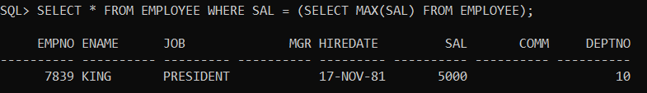

Example2:
Whose employee job is the same as the job of ‘SMITH’?
Solution:
SELECT * FROM EMPLOYEE WHERE JOB=(SELECT JOB FROM EMPLOYEE WHERE ENAME='SMITH');
When you execute the above subquery, you will get the following output.
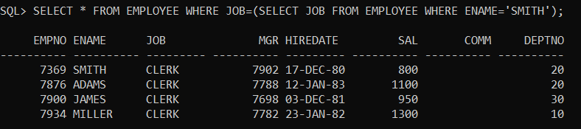

Example3:
Whose salary is more than the max salary of the job is “SALESMAN”?
Solution:
SELECT * FROM EMPLOYEE WHERE SAL>(SELECT MAX(SAL) FROM EMPLOYEE WHERE JOB='SALESMAN');
When you execute the above subquery, you will get the following output.
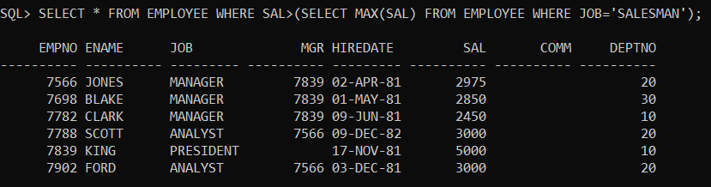

Example4:
Whose employee job is same as the job of “BLAKE” and who are earning Salary more than “BLAKE” salary?
Solution:
SELECT * FROM EMPLOYEE WHERE JOB=(SELECT JOB FROM EMPLOYEE WHERE ENAME='BLAKE') AND SAL>(SELECT SAL FROM EMPLOYEE WHERE ENAME='BLAKE');
When you execute the above subquery, you will get the following output.
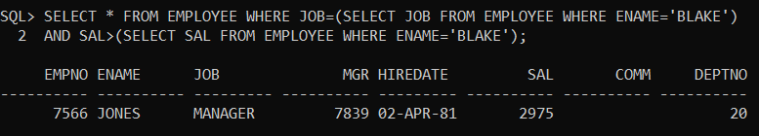

Example5:
Display senior employee?
Solution:
SELECT * FROM EMPLOYEE WHERE HIREDATE=(SELECT MIN(HIREDATE) FROM EMPLOYEE);
When you execute the above subquery, you will get the following output.
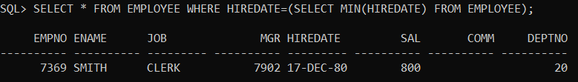

Example6:
Find the second-highest Salary from the Employee table?
Solution:
SELECT MAX(SAL) FROM EMPLOYEE WHERE SAL<(SELECT MAX(SAL) FROM EMPLOYEE);
When you execute the above subquery, you will get the following output.
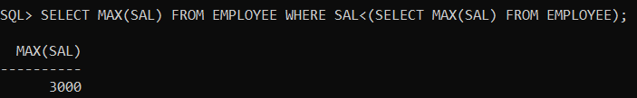

Example7:
Display employee details who are getting the Second highest Salary in the Employee table?
Solution:
SELECT * FROM EMPLOYEE WHERE SAL=(SELECT MAX(SAL) FROM EMPLOYEE WHERE SAL< (SELECT MAX(SAL) FROM EMPLOYEE));
When you execute the above subquery, you will get the following output.
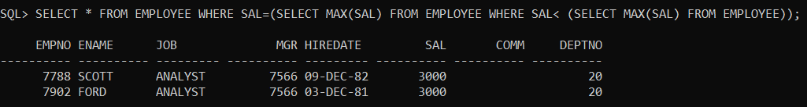

Example8:
Display employee details who are getting 3rd highest Salary in Employee table?
Solution:
SELECT * FROM EMPLOYEE WHERE SAL=
(SELECT MAX(SAL) FROM EMPLOYEE WHERE SAL<
(SELECT MAX(SAL) FROM EMPLOYEE WHERE SAL<
(SELECT MAX(SAL) FROM EMPLOYEE)));
When you execute the above subquery, you will get the following output.
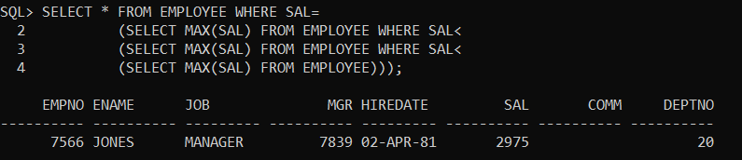

Example9:
Sum of salary of jobs if the sum of salary of jobs are more than the sum of salary of the job is ‘clerk’?
Solution:
SELECT JOB, SUM(SAL) FROM EMPLOYEE GROUP BY JOB HAVING SUM(SAL)>(SELECT SUM(SAL) FROM EMPLOYEE WHERE JOB='CLERK');
When you execute the above subquery, you will get the following output.
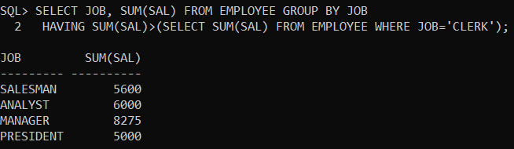

Subquery with “UPDATE”:
To update employee salary with max. salary of Employee table whose empno is 7900?
Solution:
UPDATE EMPLOYEE SET SAL=(SELECT MAX(SAL) FROM EMPLOYEE) WHERE EMPNO=7900;
When you execute the above subquery, you will get the following output.

Subquery with “DELETE”:
Delete employee details from the Employee table whose job is the same as the job of ‘SCOTT’?
Solution:
DELETE FROM EMPLOYEE WHERE JOB=(SELECT JOB FROM EMPLOYEE WHERE ENAME='SCOTT');
When you execute the above subquery, you will get the following output.

